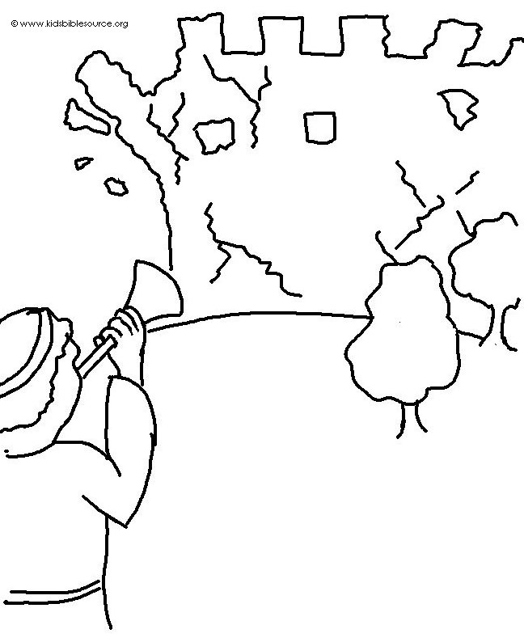
Yes, the Lord has done amazing things for us!
What joy! Psalm 126:3_{NLT}

